**Stacked Bar Chart Documentation**

**Overview**

This HTML file generates a stacked bar chart using D3.js. The chart visualizes the relationship between fruits and the quantity of different substances they contain.

**File Structure**

* **index.html**: HTML file containing the code for the stacked bar chart.
* **data_stackedXL.csv**: CSV file containing the data used for generating the stacked bar chart.

**Dependencies**

* **D3.js v4**: JavaScript library for manipulating documents based on data.
* **Bootstrap v4.5.2**: CSS framework for styling the HTML elements.

**Data**

* **data_stackedXL.csv**: CSV file containing the following attributes:
  + **group**: Name of the fruit.
  + **Calcium**: Calcium content.
  + **Fat**: Fat content.
  + **Protein**: Protein content.
  + **Fiber**: Fiber content.
  + **Vitamin C**: Vitamin C content.
  + **Vitamin A**: Vitamin A content.

**Visualization**

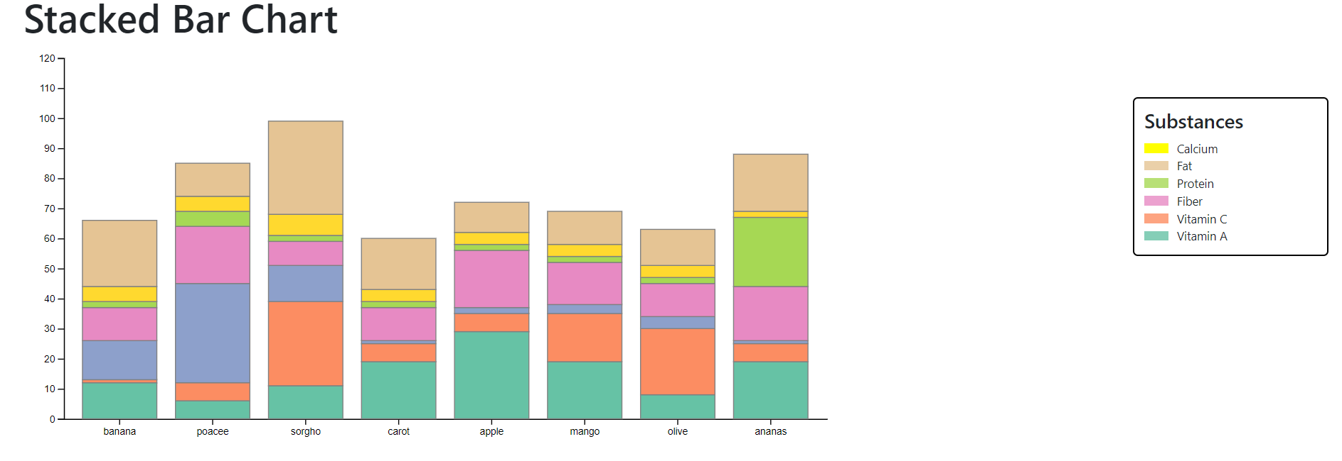

* The stacked bar chart visualizes the relationship between fruits and the quantity of different substances they contain.
* Each fruit is represented by a bar, and each substance contributes to the height of the bar.
* Substances are stacked on top of each other within each bar.
* Hovering over a bar highlights the distribution of each substance within that fruit.

**Features**

* **Hover Highlighting**:
  + When a user hovers over a bar, the chart highlights the distribution of each substance within that fruit.
  + Substances are individually colored and labeled in the legend for easy identification.

**Legend**

* **Substances**:
  + Calcium: Yellow
  + Fat: Light Brown
  + Protein: Green
  + Fiber: Pink
  + Vitamin C: Orange
  + Vitamin A: Light Blue

**Usage**

1. Ensure that the **data_stackedXL.csv** file is in the same directory as the HTML file.
2. Open **index.html** in a web browser to view the stacked bar chart.